Arithmetic Operators in VI Editor:

The VI editor is known for its versatility across the tech world. We can perform numerous operations in it. Here we are going to explore the arithmetic operations that can be performed in the VI editor. For learning them, first we should be familiar with all the commands we are going to use in it.

Commands to be used:

* Echo: echo command in linux is used to display line of text/string that are passed as an argument.
* Read: The command read in the Linux is used to read the input from the keyboard.
* Sh : It is a command language interpreter that executes commands read from a [command line](https://www.computerhope.com/jargon/c/commandi.htm)[string](https://www.computerhope.com/jargon/s/string.htm), the [standard input](https://www.computerhope.com/jargon/s/stdin.htm), or a specified [file](https://www.computerhope.com/jargon/f/file.htm).

Addition, subtraction, multiplication and division is performed as stated.

The following screenshot is of the vi editor file named ‘arth’ I created:

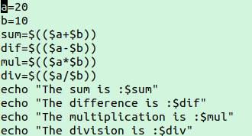

The output is as follows:

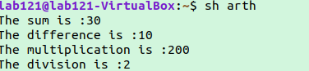

Logical Operations in VI editor:

For this first we must know the logical operators which are going to be used.

* ! :This is logical negation. This inverts a true condition into false and vice versa.
* -o :This is logical OR. If one of the operands is true, then the condition becomes true.
* -a :This is logical AND. If both the operands are true, then the condition becomes true otherwise false.

In the program I have used 2 more functionalities, -gt stands for greater than and -lt stands for less then.

Here is the screenshot:

